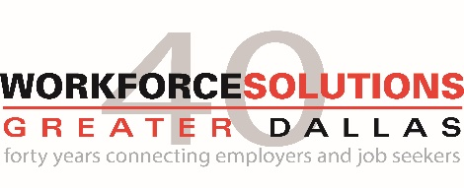
Workforce Solutions Greater Dallas invites public comments for the February 15th Board of Drectors meeting.

Organization:
Date:
Contact:
Title:

Public Comment:

