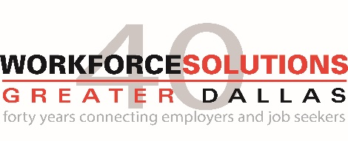
Workforce Solutions Greater Dallas invites public comments for the 2023-2024 WIOA Plan Modification. The public comment period begins on January 30th – February 28th, 2023. Please see the Plan Summary. For the full WOIA Plan, see the link on the homepage below. Email completed form to: info@wfsdallas.com

Organization:
Date:
Contact:
Title:

Public Comment:

