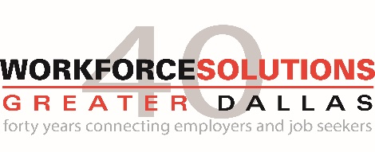
Workforce Solutions Greater Dallas invites public comments for the May 17th Board of Directors’ meeting.

Organization:
Date:
Contact:
Title:

Public Comment:

